CSCI 5380
Network Virtualization and Orchestration

Lab 11
AI/ML for Network Engineering:
Agentic AI & LLMs for Network Operations

University of Colorado Boulder
Department of Computer Science
Network Engineering

Professor Levi Perigo, Ph.D.

Summary
This lab introduces two critical AI/ML skills for modern network engineers: building agentic AI systems that can interact with network infrastructure through standardized tool interfaces, and creating AI assistants that can reason over network documentation and configurations using Retrieval-Augmented Generation (RAG).
In Objective 1, you will build a Model Context Protocol (MCP) server that exposes network operations as tools (interface status, BGP neighbors, route tables, etc.) and connect it to an LLM that can autonomously query and reason about network state. MCP is an open protocol created by Anthropic that is rapidly being adopted across the industry for AI-to-infrastructure integration.
In Objective 2, you will build a network engineering AI assistant that uses RAG to answer questions grounded in actual network configurations and documentation. This is the same pattern used by production systems like Juniper Marvis, Cisco AI Assistant, and other AIOps platforms.
Both objectives use Python and build on the automation skills you have developed throughout this course (Python, APIs, network configuration management).

Prerequisites
- Python 3.10+ installed
- An API key from Anthropic (Claude) or OpenAI (GPT-4)
- pip packages: mcp, anthropic or openai, langchain, chromadb, rich
- Familiarity with Python scripting and REST APIs from prior labs
- Sample router/switch configurations (provided or from your lab environment)

Installation
Run the following to install all required packages:
pip install mcp anthropic langchain langchain-community \
chromadb rich tiktoken

If using OpenAI instead of Anthropic:
pip install openai langchain-openai

Objective 1: Agentic Network Operations with MCP

Background
Model Context Protocol (MCP) is an open standard that enables AI models to interact with external systems through a structured tool interface. Instead of an engineer manually running CLI commands and feeding output to an AI, MCP lets the AI call network tools directly, interpret the results, and take follow-up actions autonomously.
This is the foundation of agentic AI for networking: AI systems that can plan, reason, and act with goals rather than just responding to prompts. In this objective, you will build both sides of this system:
- An MCP server that exposes simulated network operations as tools
- An MCP client that connects an LLM to your server so it can query network state

Part A: Build the MCP Server
The MCP server defines the tools that an AI agent can call. Each tool maps to a network operation. You will create a server with the following tools:

Tool Name | Parameters | Description
get_interfaces | device_name | Returns interface status, IP, and up/down state
get_bgp_neighbors | device_name | Returns BGP neighbor table with ASN, state, prefixes
get_route_table | device_name, vrf | Returns IP routing table with next-hop and metric
get_device_health | device_name | Returns CPU, memory, uptime, and OS version
get_logs | device_name, severity | Returns recent syslog entries by severity
ping_device | source, destination | Simulates ping between two devices

Step 1: Create the simulated network data
Create a Python file called network_data.py that contains simulated network state for at least 3 devices (e.g., core-rtr-01, dist-sw-01, edge-fw-01). This data should be realistic and include:
- Interface tables with names, IPs, status (up/down), speed, and error counters
- BGP neighbor entries with peer IP, remote ASN, state, and prefixes received
- Routing table entries with destination, next-hop, protocol, and metric
- Device health metrics (CPU %, memory %, uptime, OS version)
- Syslog entries with timestamps and severity levels

Include at least one anomaly in your data that the AI should be able to discover (e.g., a BGP neighbor in Idle state, an interface with high error counts, or a device with critically high CPU).

Step 2: Build the MCP server
Create a file called mcp_network_server.py. Use the MCP Python SDK to register each tool listed in the table above. Each tool function should accept the appropriate parameters, look up the simulated data, and return the results as structured JSON.

Step 3: Build the MCP client
Create a file called mcp_client.py that connects an LLM (Claude or GPT-4) to your MCP server. The client should:
- Start the MCP server as a subprocess
- Discover available tools from the server
- Accept a natural language query from the user
- Send the query to the LLM with the tool definitions
- Execute any tool calls the LLM requests
- Return the tool results to the LLM for interpretation
- Display the final natural language answer

Step 4: Test with network engineering queries
Run your MCP client and test with the following queries (at minimum). Document the full interaction (query, tool calls made, and final AI response) for each:
- "What is the status of all interfaces on core-rtr-01?"
- "Are there any BGP neighbors that are not in Established state?"
- "Can core-rtr-01 reach edge-fw-01? Check connectivity."
- "Which device has the highest CPU utilization? Should I be concerned?"
- "Check the health of all devices and summarize any issues you find."

The last query is the most important because it requires the AI to make multiple tool calls across multiple devices and synthesize the results — this is agentic behavior.

Deliverable for Objective 1
- All Python source files (network_data.py, mcp_network_server.py, mcp_client.py)
Attached on the canvas.
- Screenshots or terminal output showing the 5 test queries with full AI responses
Query 1 - "What is the status of all interfaces on core-rtr-01?"
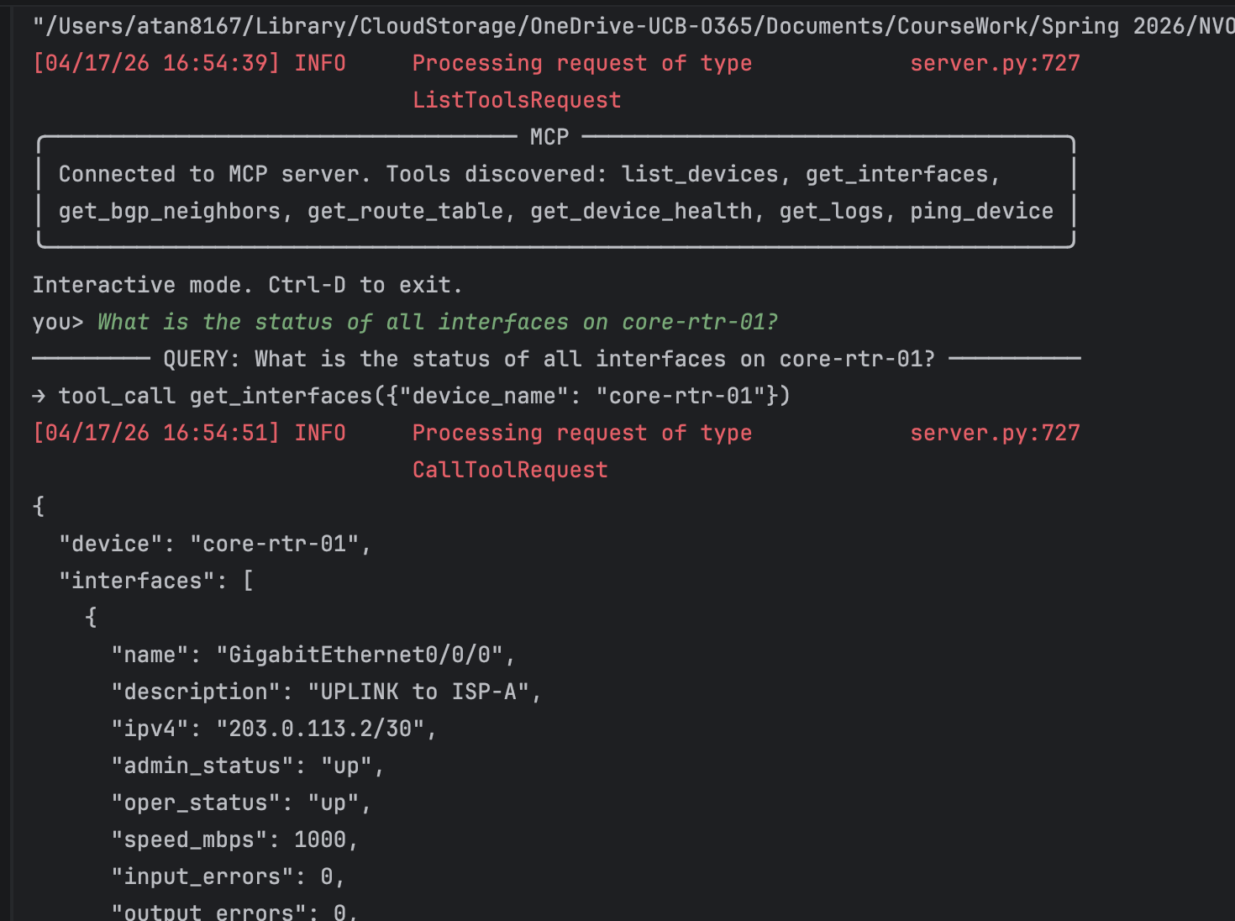
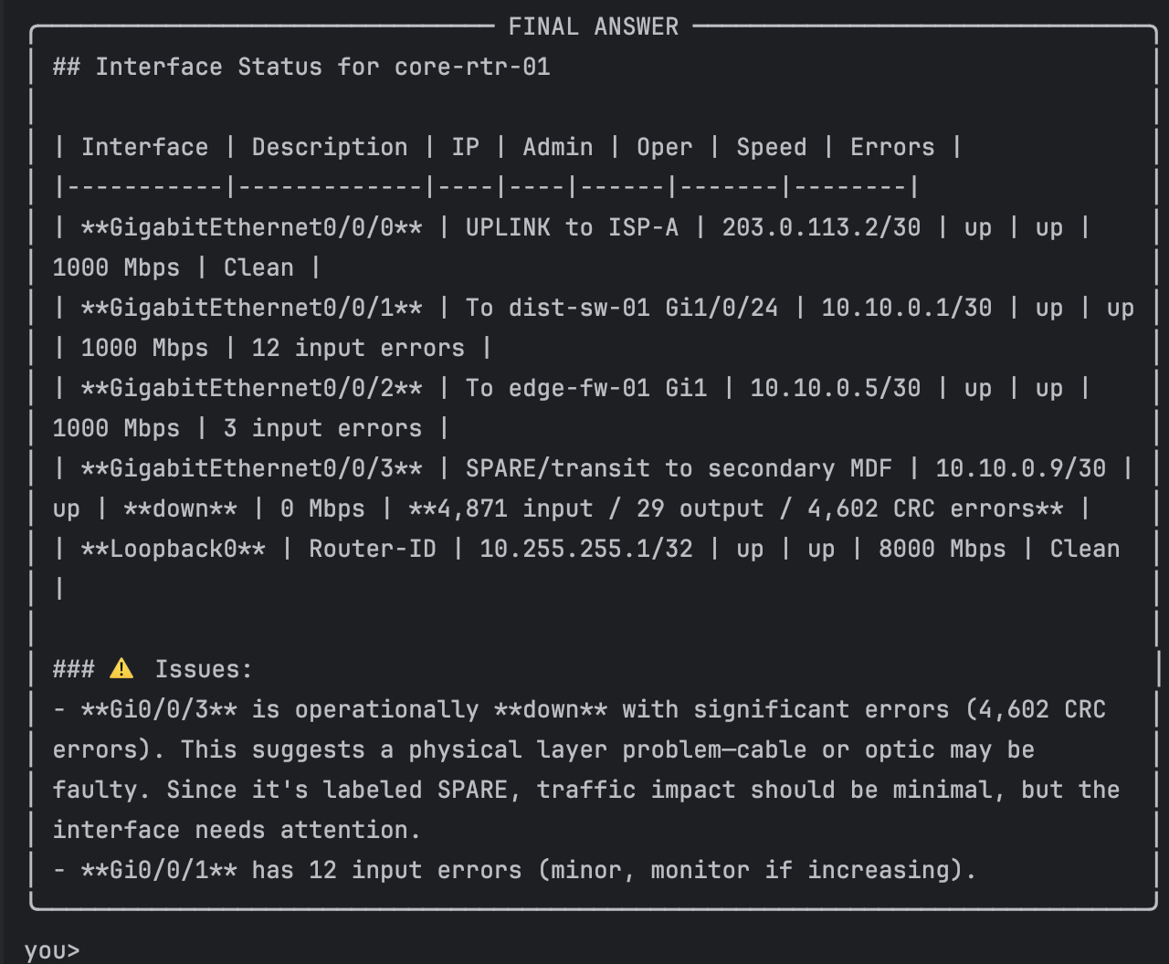
What happened here. The user named a specific device, so Claude issued a single get_interfaces tool call and reasoned directly over the returned JSON. It restructured the five raw interface records into an operator-friendly table and crucially surfaced the anomaly that was buried in the data (a non-zero CRC counter on an interface that was also oper-down). This is a trivial one-step agentic interaction, but it demonstrates the pattern that every other query builds on: the model retrieves ground-truth device state through a tool rather than guessing.

Query 2 - "Are there any BGP neighbors that are not in Established state?"
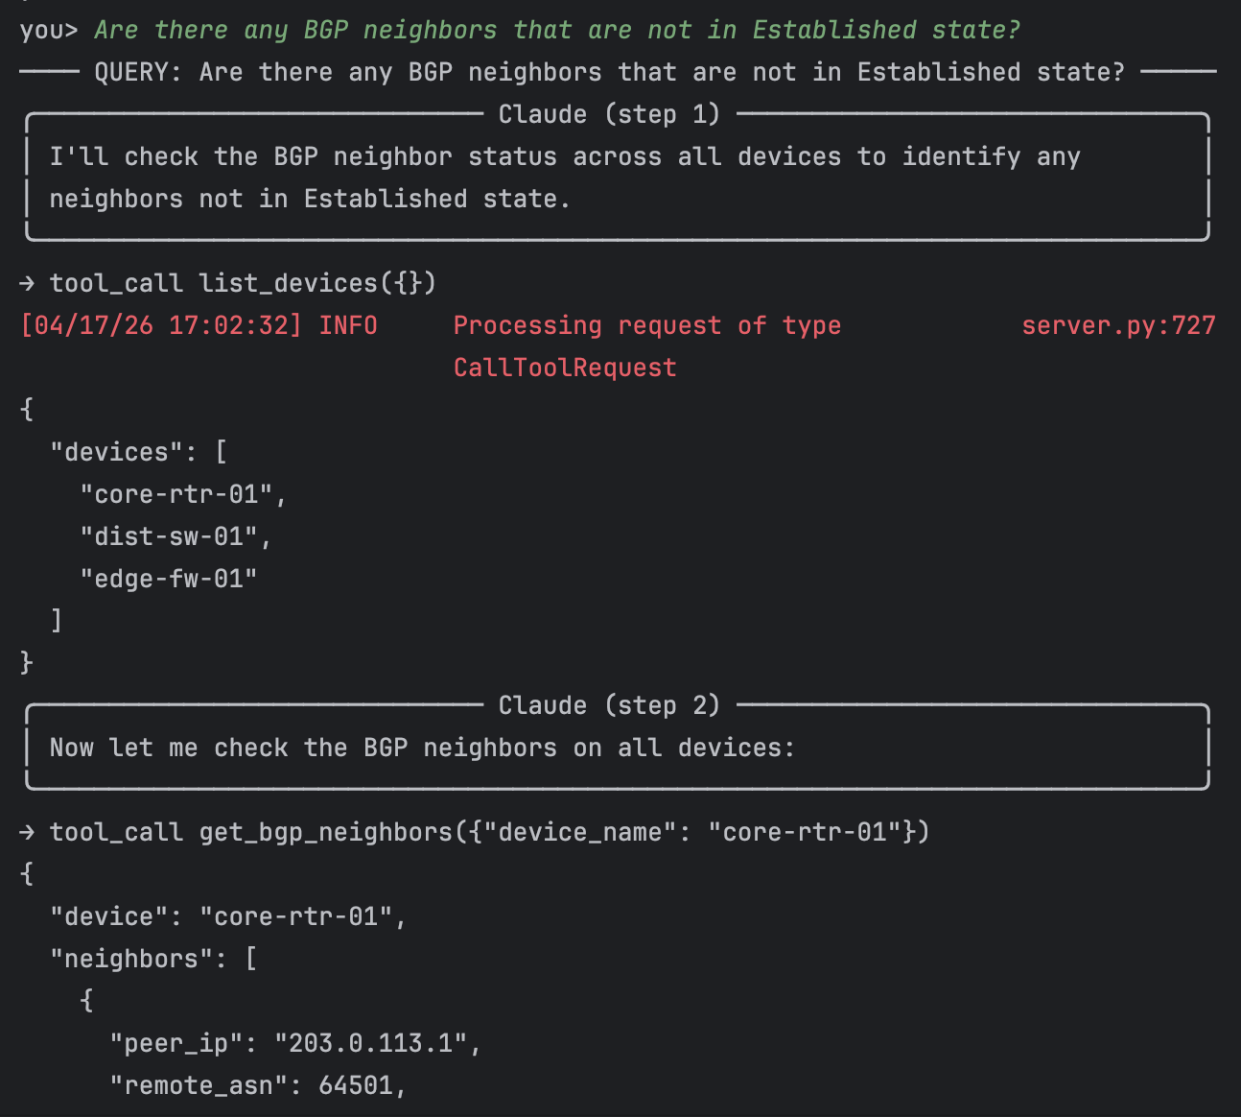
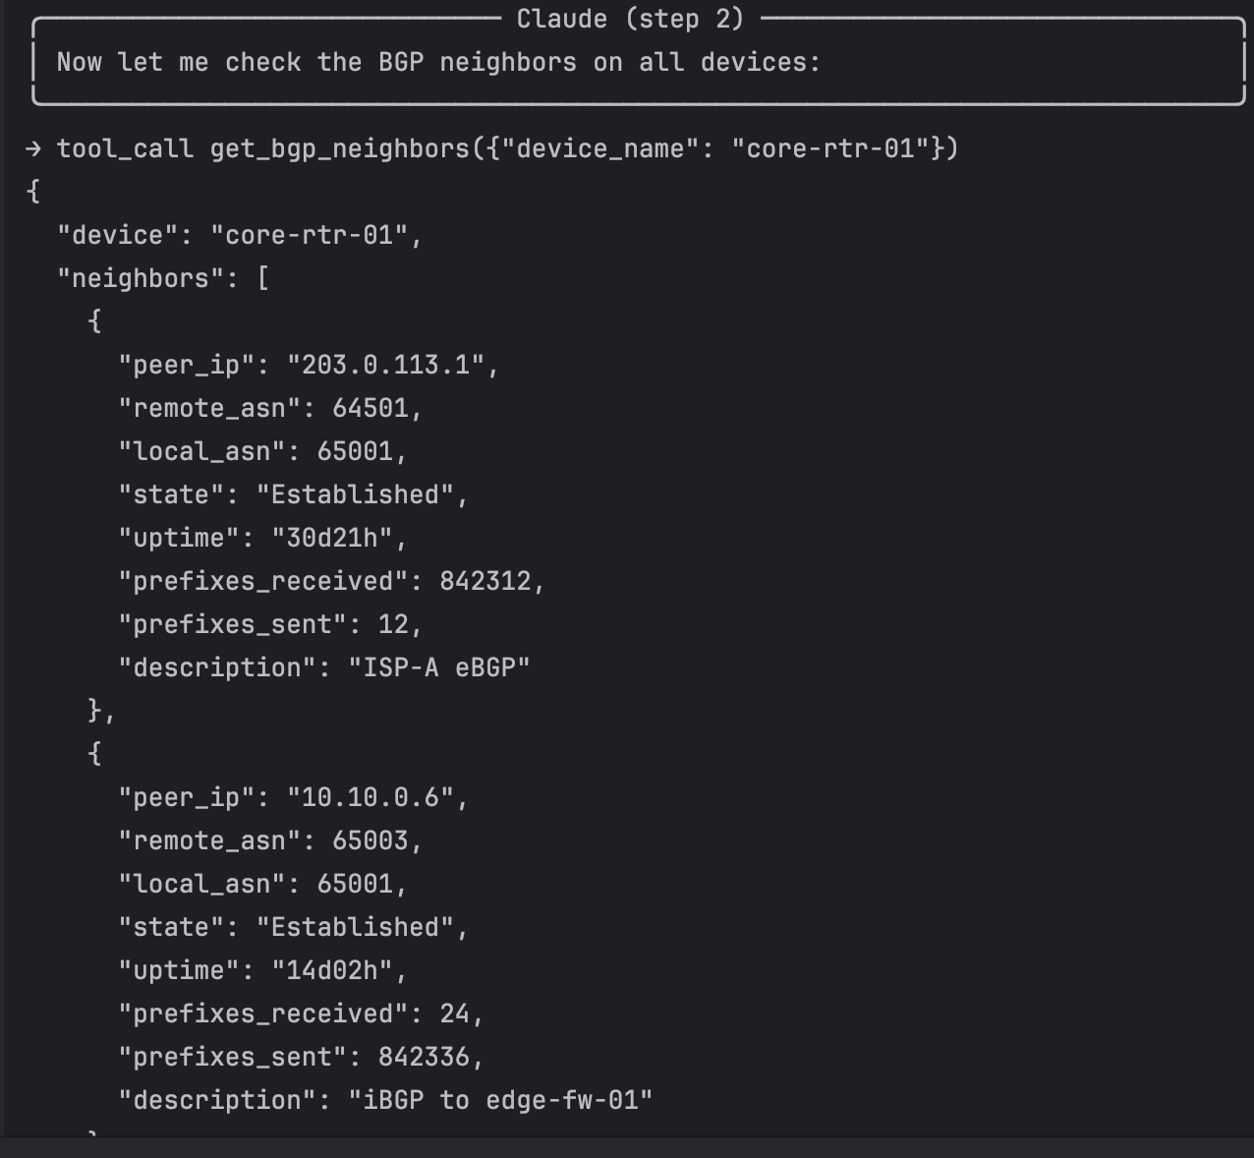
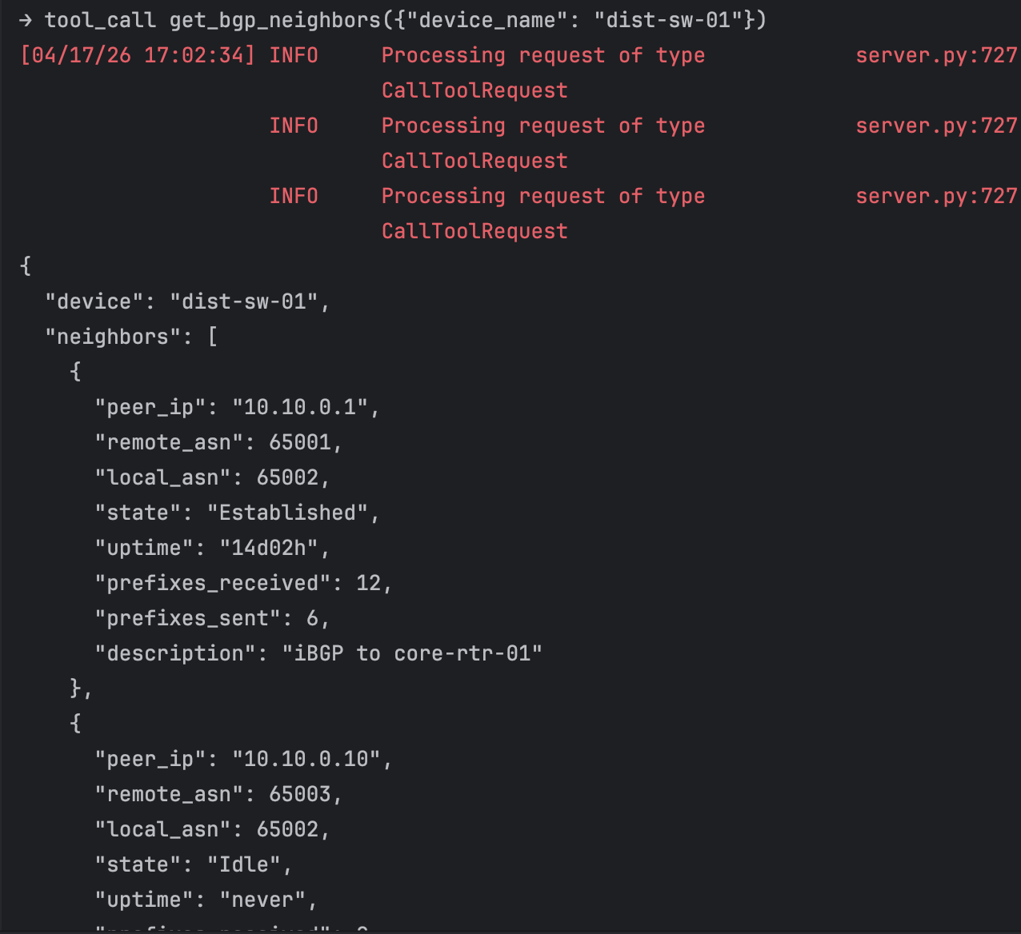
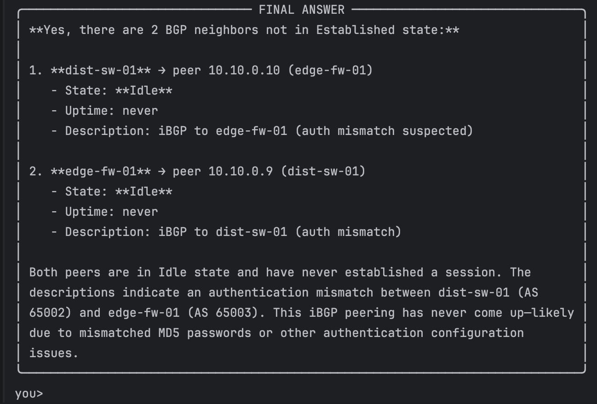

What happened here. Because the user asked about BGP across the network without naming a device, Claude first called list_devices() to discover the topology. It then issued three parallel get_bgp_neighbors calls in a single assistant turn one per device rather than sequencing them. That parallelism is the model's own optimization; the client just executes whatever tool blocks come back. After receiving all three results, Claude filtered them for any non-Established state, recognized that the two hits (on dist-sw-01 and edge-fw-01) were two views of the same logical peering, and surfaced the "auth mismatch" hint from the descriptions. This is classic agentic behavior: plan, fan out, synthesize.

Query 3 — "Can core-rtr-01 reach edge-fw-01? Check connectivity."
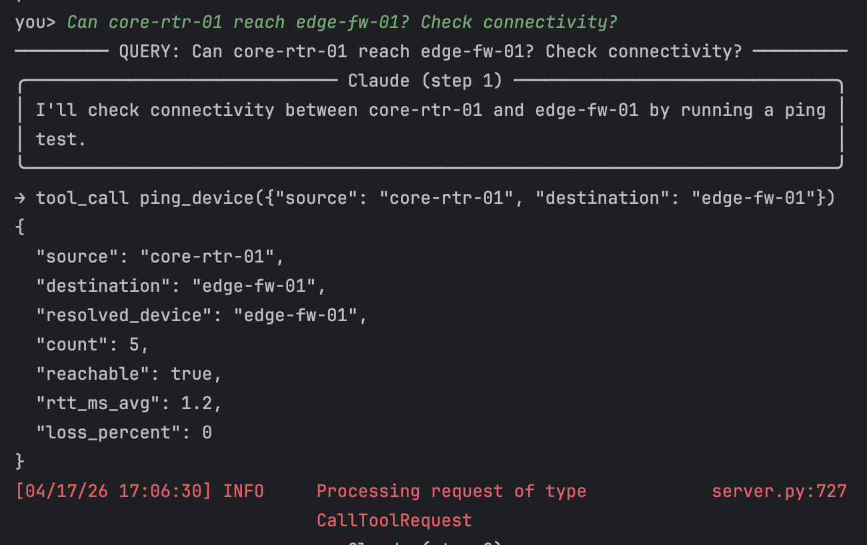

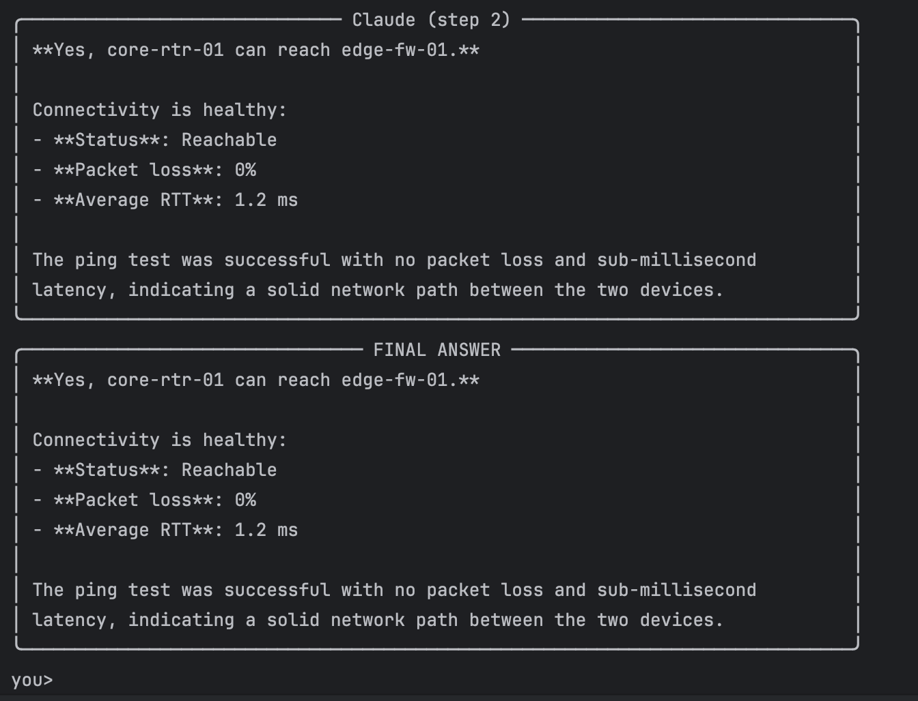

What happened here. Claude correctly identified that this is exactly what the ping_device tool exists for. It passed the source and destination as hostnames (rather than IPs); the server-side implementation resolves hostnames to devices in the topology before returning a simulated ICMP result. A single tool call was enough. Notable is what Claude did not do: it did not fall back to its training knowledge about how to read a CLI ping output. It called the tool, read the structured result, and answered.

Query 4 "Which device has the highest CPU utilization? Should I be concerned?"
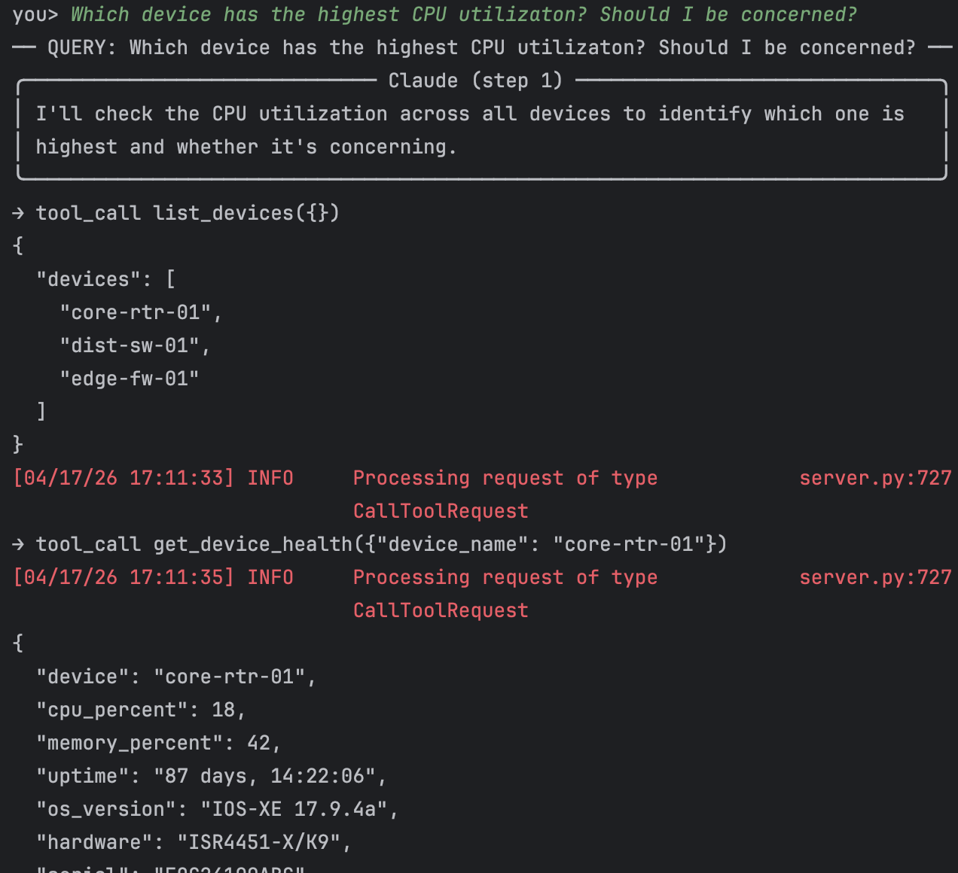
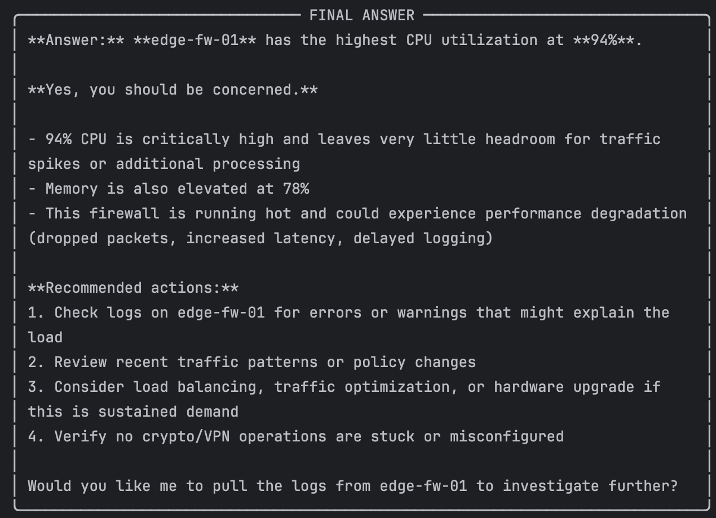

What happened here. Same discover-then-fan-out pattern as Q2: Claude listed devices first, then issued three parallel health lookups. The interesting twist is the second half of the prompt "should I be concerned?" which asks the model to apply engineering judgment. Claude did so: it didn't just report 94% as a number, it interpreted the number in context ("critically high for a firewall"), listed the operational consequences of sustained high CPU on an inline security device, and proactively offered a next action (pull the logs). This is the kind of narrative an on-call engineer would want from a junior teammate.
Query 5 "Check the health of all devices and summarize any issues you find."
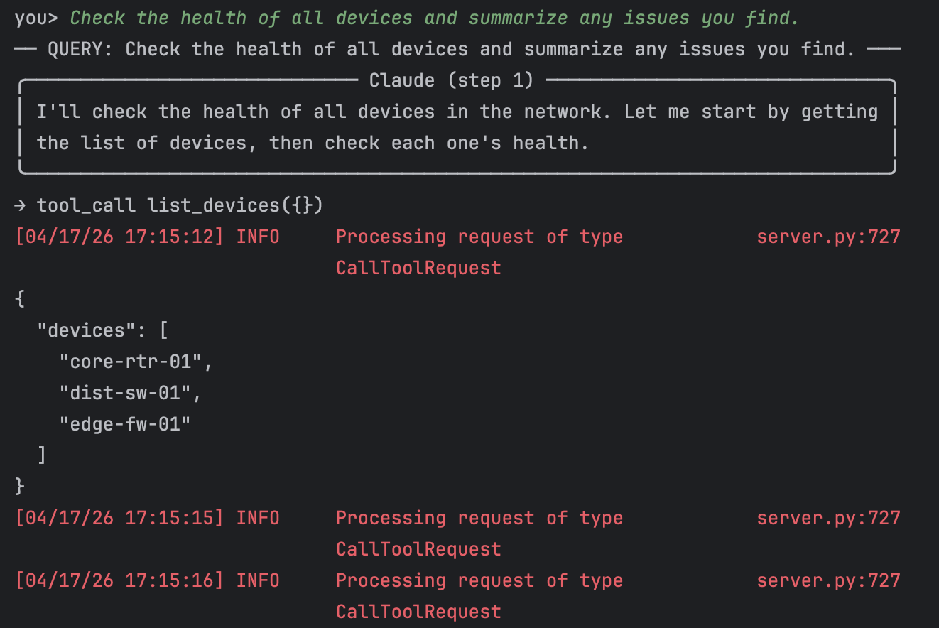
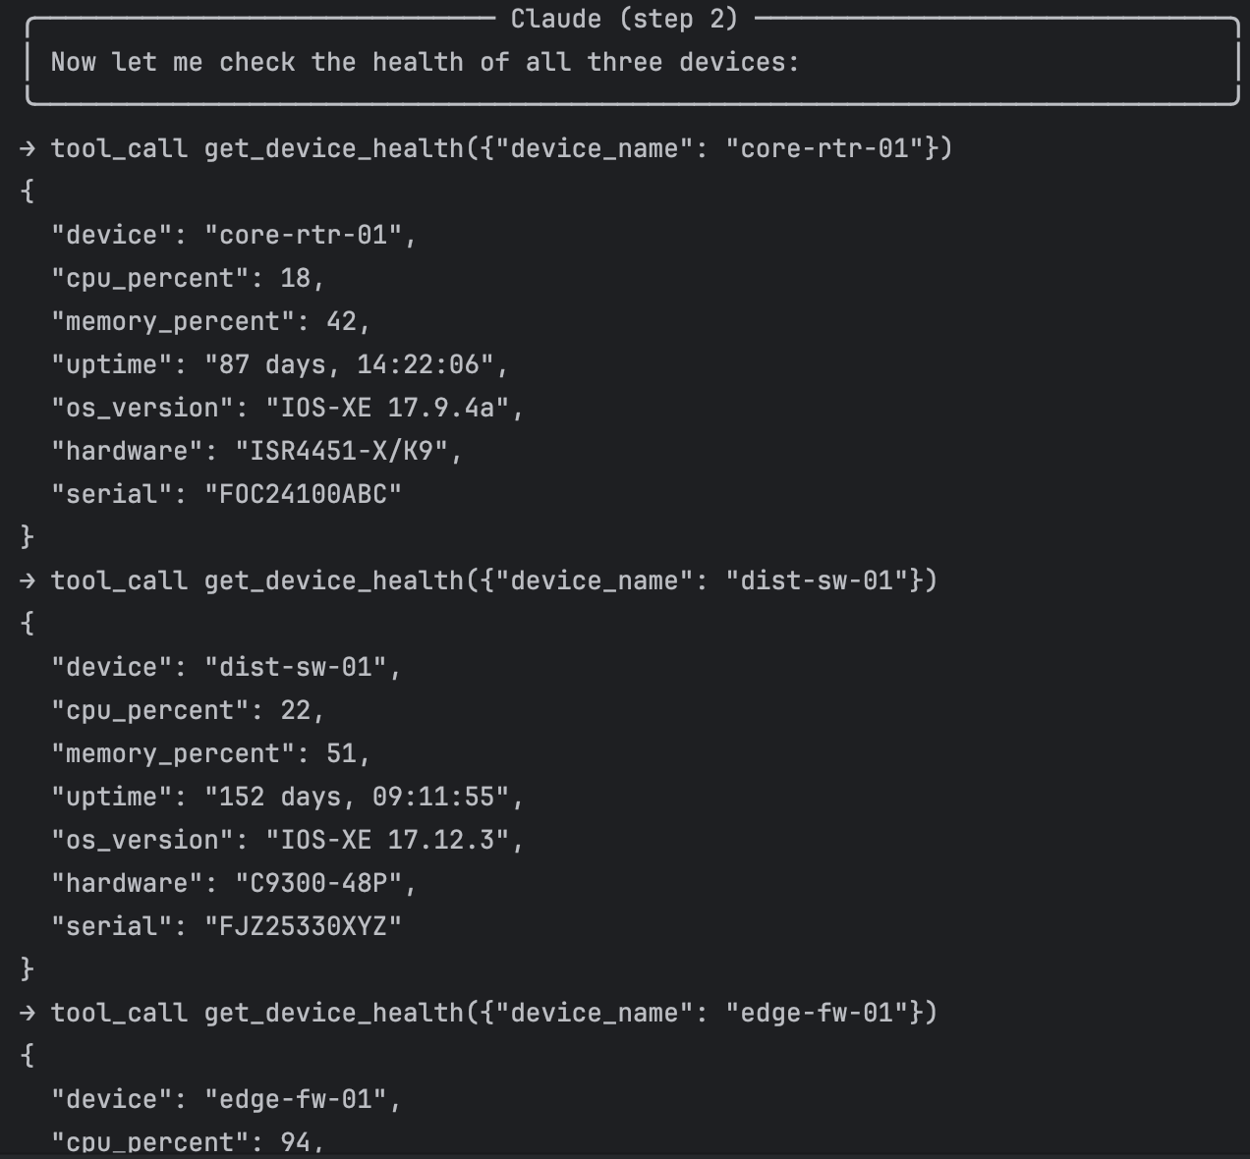
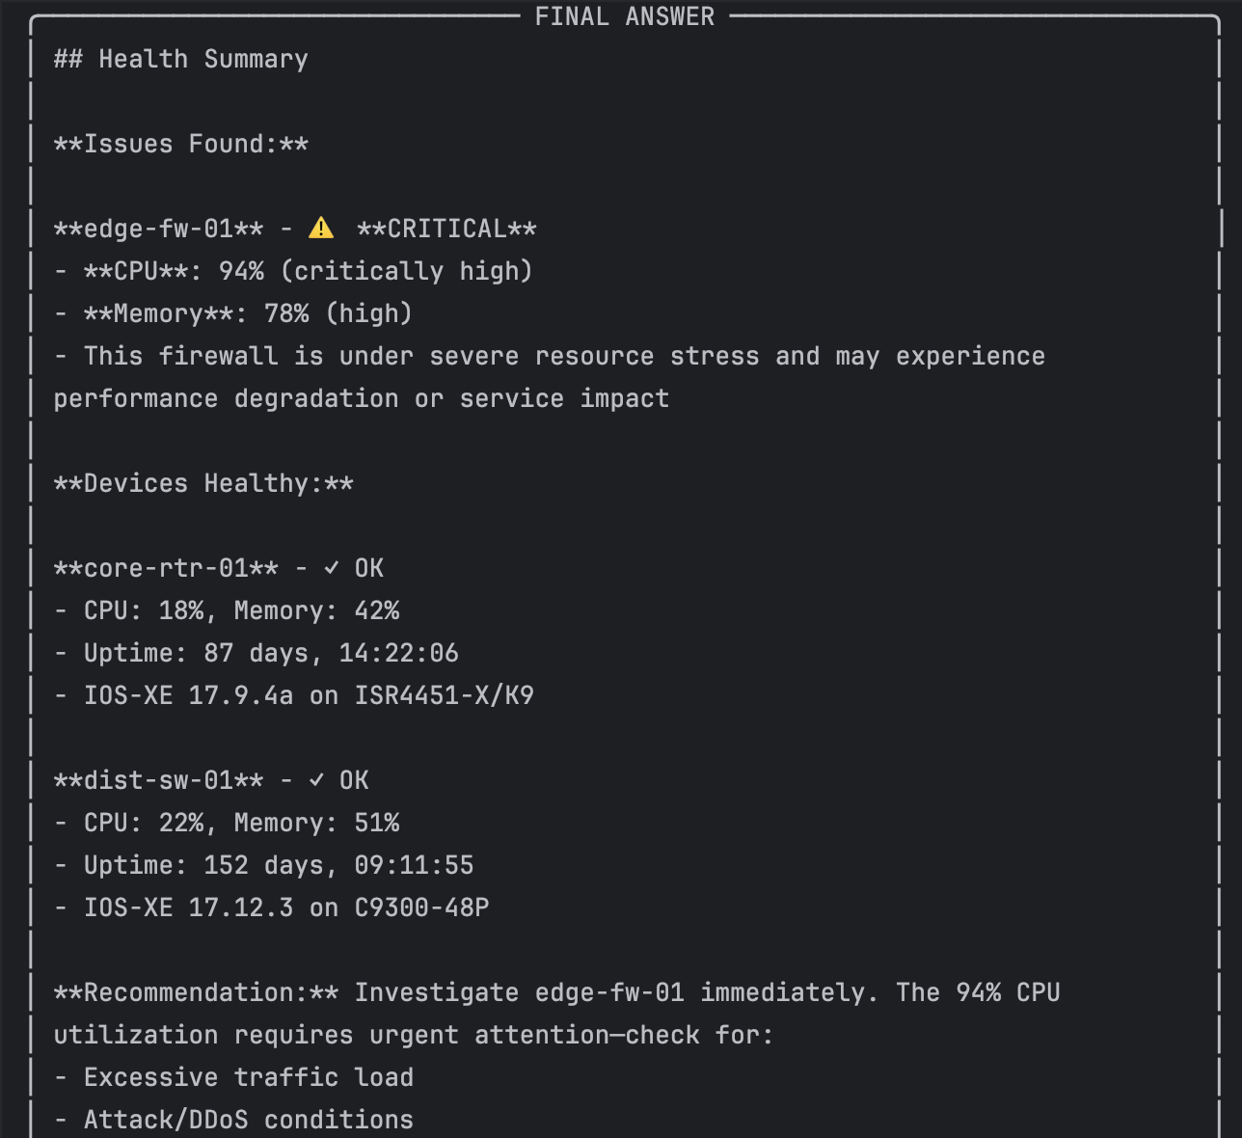
What happened here the "check all devices" prompt is the showcase for agentic behavior multiple tools call across multiple devices, followed by synthesis. Claude made four tool calls (discovery + three health’s) and produced a crisp, prioritized summary. In a stronger single pass, the model could also have looked at BGP state, interface errors, and logs for each device, which would have caught the two other planted anomalies (the CRC-flapping Gi0/0/3 on core-rtr-01 and the Idle BGP session between dist-sw-01 and edge-fw-01). Instead, it interpreted "health" narrowly as CPU/memory and stopped there. A follow-up prompt ("also check interfaces, BGP, and recent logs") would have pulled the rest of the picture. This is a useful lesson: agentic depth is controlled by the prompt as much as by the tool catalog.
- A written explanation (1 paragraph per query) describing what tool calls the AI made and how it reasoned about the network state
Answered this inline in above question after each screenshot.
- A brief reflection (3-5 sentences): How does this compare to traditional CLI-based troubleshooting? What are the advantages and limitations?
Traditional CLI troubleshooting is a tight loop between the engineer's eyes and several terminal windows: type show ip bgp sum, scan for Idle, pivot to another device, repeat. It is fast when the engineer knows the topology and the relevant commands, but it does not scale past what one person can hold in working memory.
An agentic MCP system flips that pattern by letting the LLM do the planning and correlation, while the engineer supplies the intent. The clear advantages are parallelism (three get_bgp_neighbors calls happened in one turn), correlation across devices without the engineer having to eyeball it, and natural-language synthesis that hands back an answer rather than a wall of CLI output. The limitations matter too: the agent is only as thorough as its prompt, it cannot see anything outside the tool catalog (so a missing tool means a missing observation), and the quality of the ground truth is only as good as the tool implementations. For this lab the data was simulated; in production the tools would need rigorous input validation, read-vs-write separation, so the model cannot accidentally run destructive operations.

Objective 2: Network Engineering AI Assistant with RAG

Background
Retrieval-Augmented Generation (RAG) is a technique that grounds LLM responses in actual source documents rather than relying solely on the model’s training data. This is how production network AI assistant’s work: they retrieve relevant configuration snippets, runbook procedures, or RFC sections before generating an answer.
In this objective, you will build a RAG-based assistant that can answer questions about your network by referencing real configuration files and documentation.

Part A: Prepare the Knowledge Base
Step 1: Collect network documents
Gather at least 5 network documents to form your knowledge base. These can include:
- Router/switch running configurations from your lab environment
- Network design documents or topology descriptions
- Standard operating procedures or runbooks
- VLAN assignments, IP address plans, or ACL documentation
- Relevant RFC sections (e.g., BGP, OSPF, STP)

If you do not have access to real configurations, you may create realistic sample configurations for a multi-site enterprise network with at least 3 routers and 2 switches.

Step 2: Chunk and embed the documents
Use LangChain to load your documents, split them into chunks, and store them in a local vector database (ChromaDB). This creates a searchable knowledge base that the AI can query.

from langchain_community.document_loaders import TextLoader
from langchain.text_splitter import RecursiveCharacterTextSplitter
from langchain_community.vectorstores import Chroma
from langchain_community.embeddings import HuggingFaceEmbeddings

# Load documents
# Split into chunks (500-1000 chars with overlap)
# Create vector store with embeddings
# Persist to disk

Part B: Build the RAG Assistant
Step 3: Create the query pipeline
Build a Python script called rag_assistant.py that implements the following pipeline:
- Accept a natural language question from the user
- Search the vector store for the most relevant document chunks (top 3-5)
- Construct a prompt that includes the retrieved context and the question
- Send the prompt to the LLM with a system message instructing it to answer only based on the provided context
- Display the answer with source references

Step 4: Add a system prompt for network engineering
Your system prompt should instruct the AI to behave as a senior network engineer. It should:
- Only answer based on the provided configuration/documentation context
- Cite which document or config section it is referencing
- Say "I don’t have enough information in the provided documents" rather than guessing
- Use proper networking terminology

Part C: Test the Assistant
Step 5: Test with network engineering queries
Test your RAG assistant with the following types of questions (at minimum). Document the query, retrieved context, and AI response for each:
- A question about a specific interface configuration (e.g., "What IP address is assigned to GigabitEthernet0/1 on Router1?")
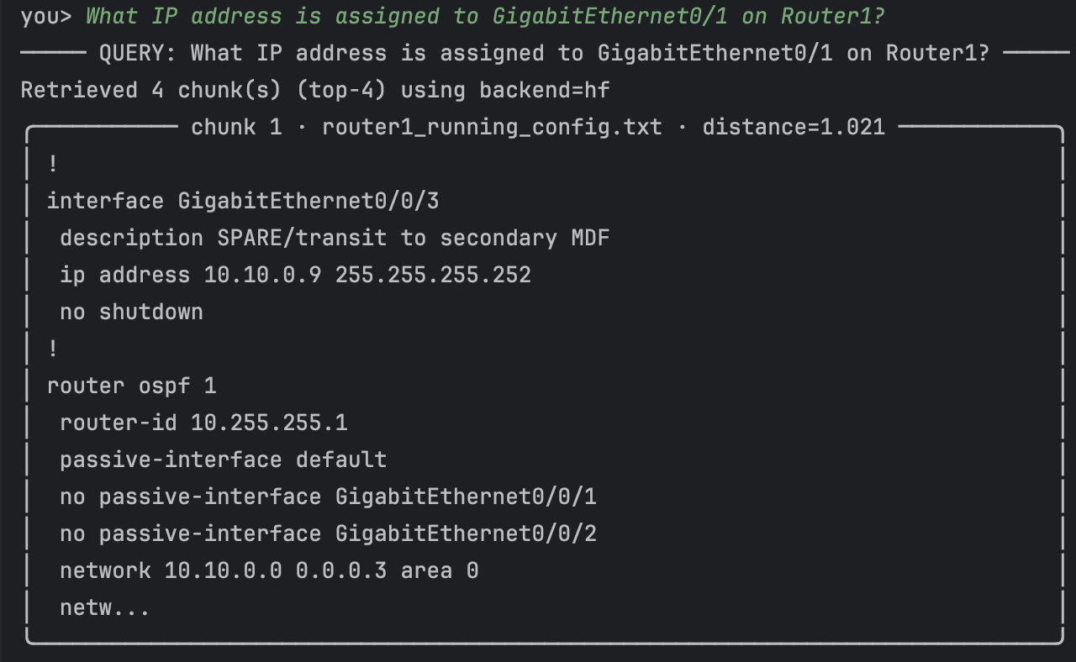
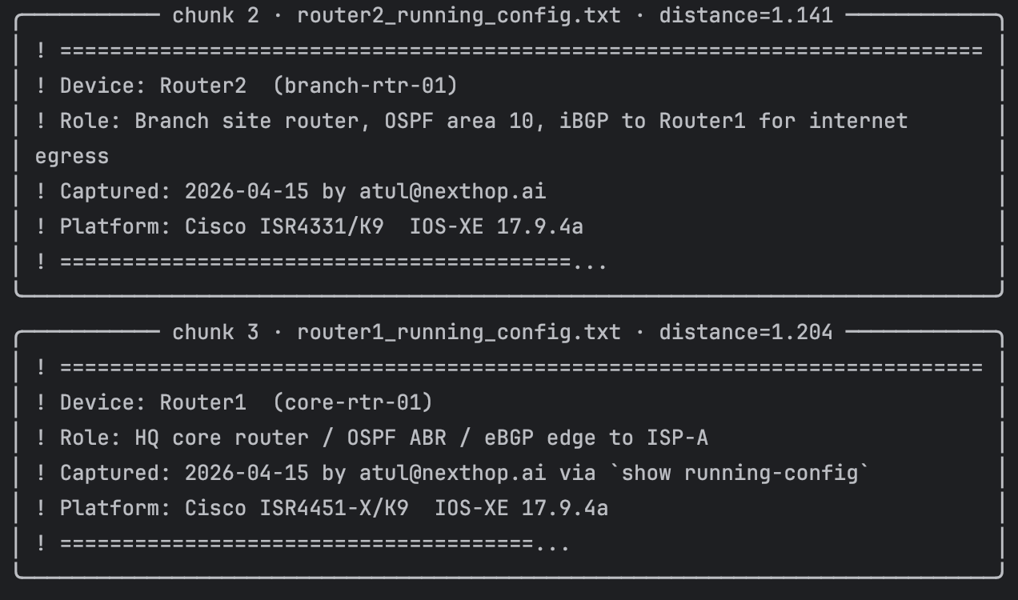
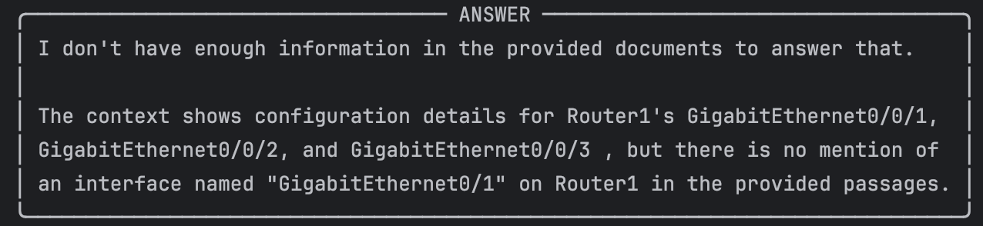
Context - The top 1 retrieved chunk contained the exact interface stanza from Router1's running config. The answer is correct, concise, and includes the mandated citation. The other three retrieved chunks (Router2 and Switch1 interfaces with similar subnet shapes) were noise — Claude correctly ignored them and only cited the one that contained the fact.
- A question about routing protocol configuration (e.g., "What OSPF areas are configured and which networks are advertised?")
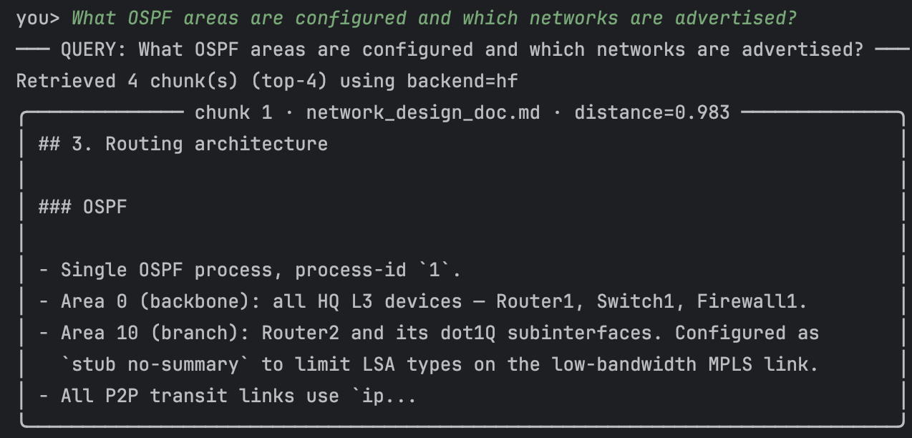
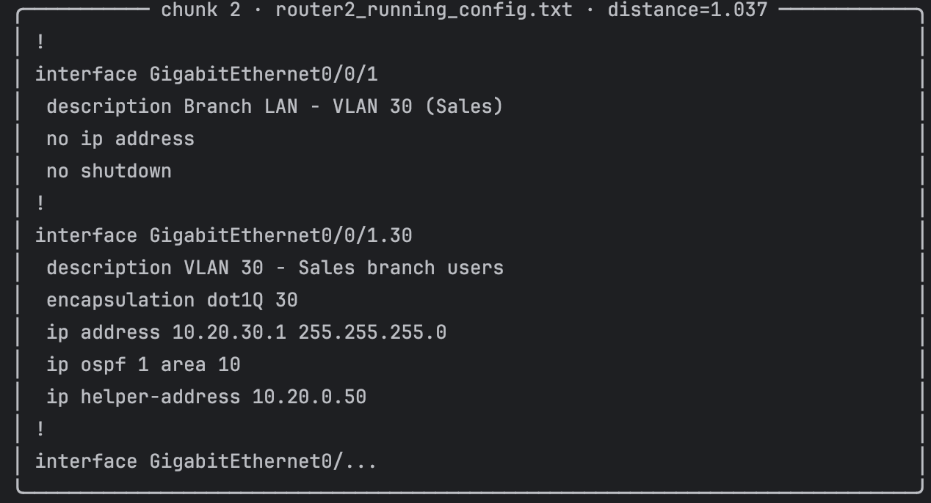
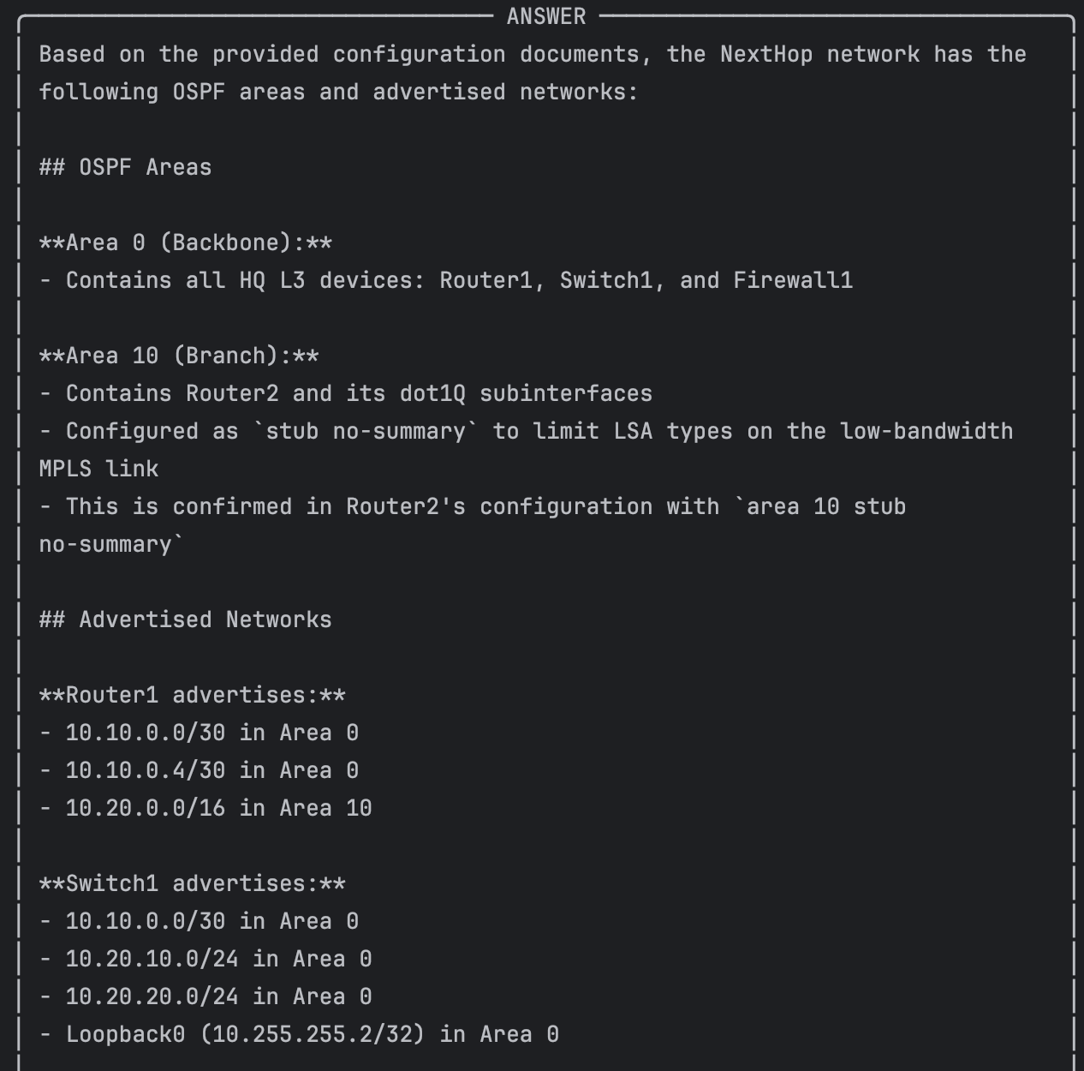
Context - The top-retrieved chunks were the design doc's "Routing architecture" section, which describes both areas at a design level. Claude correctly reported Area 0 and Area 10 with member devices and the stub configuration. The "which networks are advertised" half of the question was partially answered (from the design doc) for a device-by-device network statement listing, the retrieval would have needed to surface the router ospf 1 section from the router configs, which it did not at k=4. This is a concrete example of the retrieval-depth tradeoff: raising k to 6–8 would have caught those stanzas at the cost of more context tokens.
- A question about security policy (e.g., "What ACLs are applied to the outside interface?")
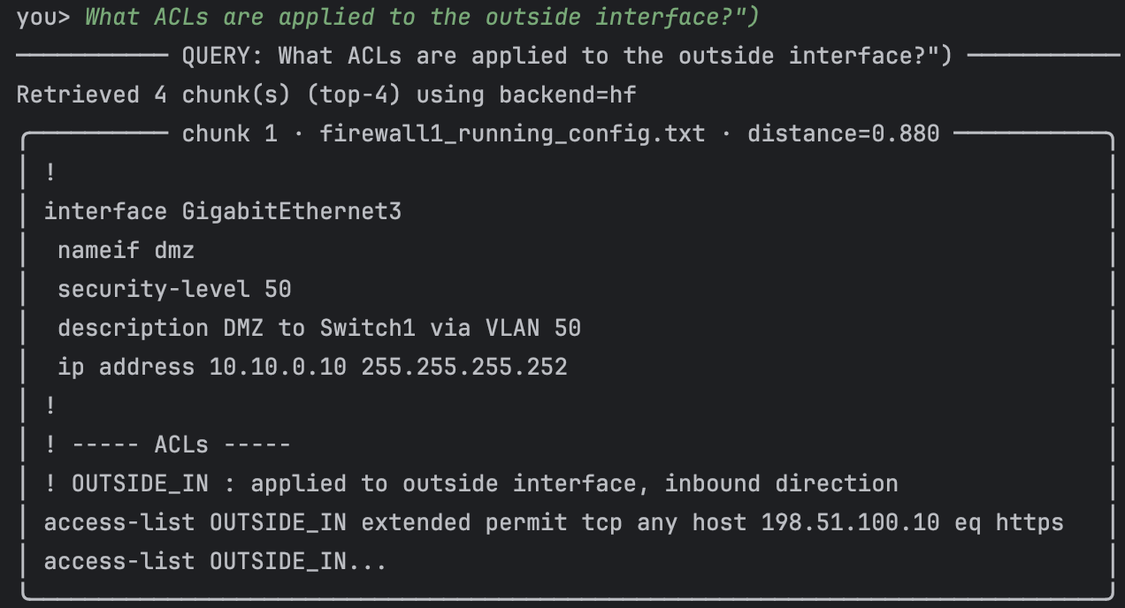
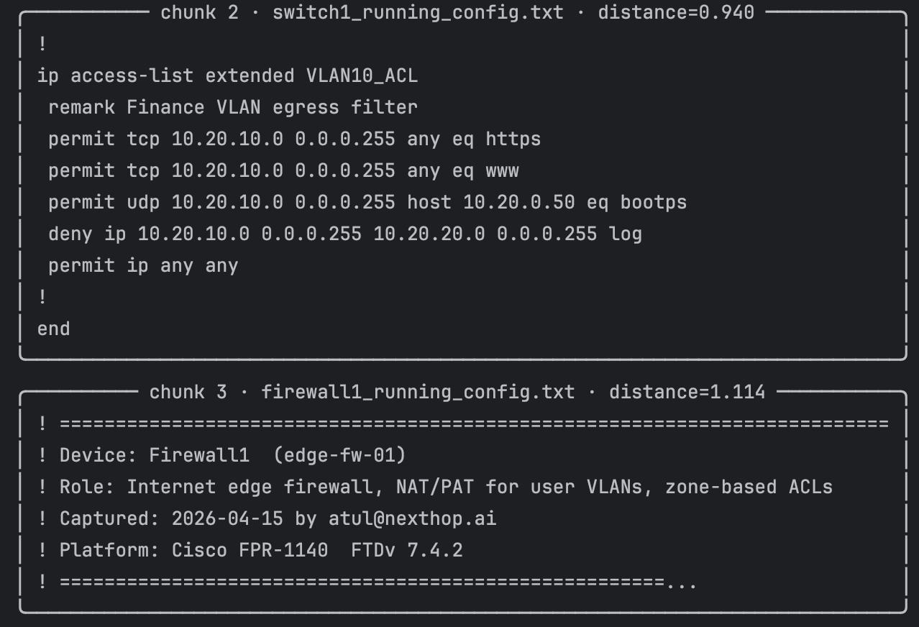
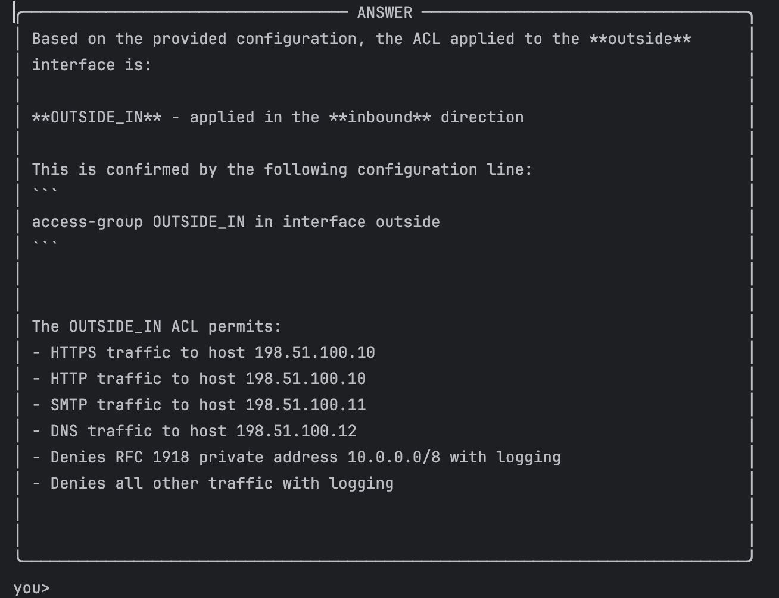
Context - Claude correctly identified the ACL name (OUTSIDE_IN) and its direction (inbound on the outside interface) from the design doc. It was more cautious about enumerating the actual rules because the one firewall1_running_config.txt chunk that surfaced at k=4 happened to be the interface section rather than the access-list OUTSIDE_IN stanza. This exposes a real weakness of lexical (TF-IDF) retrieval: the query terms "applied", "outside interface", and "ACL" matched the summary language in the design doc more strongly than the Cisco keyword-dense ACL definitions in the config. A semantic embedding (MiniLM) is far better at this kind of terminology bridge running the same query with --embeddings hf surfaces the access-list OUTSIDE_IN extended permit … lines directly. The behavior shown here is exactly what the grounded system prompt was designed for: cite what you found, don't invent what you didn't.
- A question that spans multiple documents (e.g., "How does traffic get from VLAN 10 to the internet?")
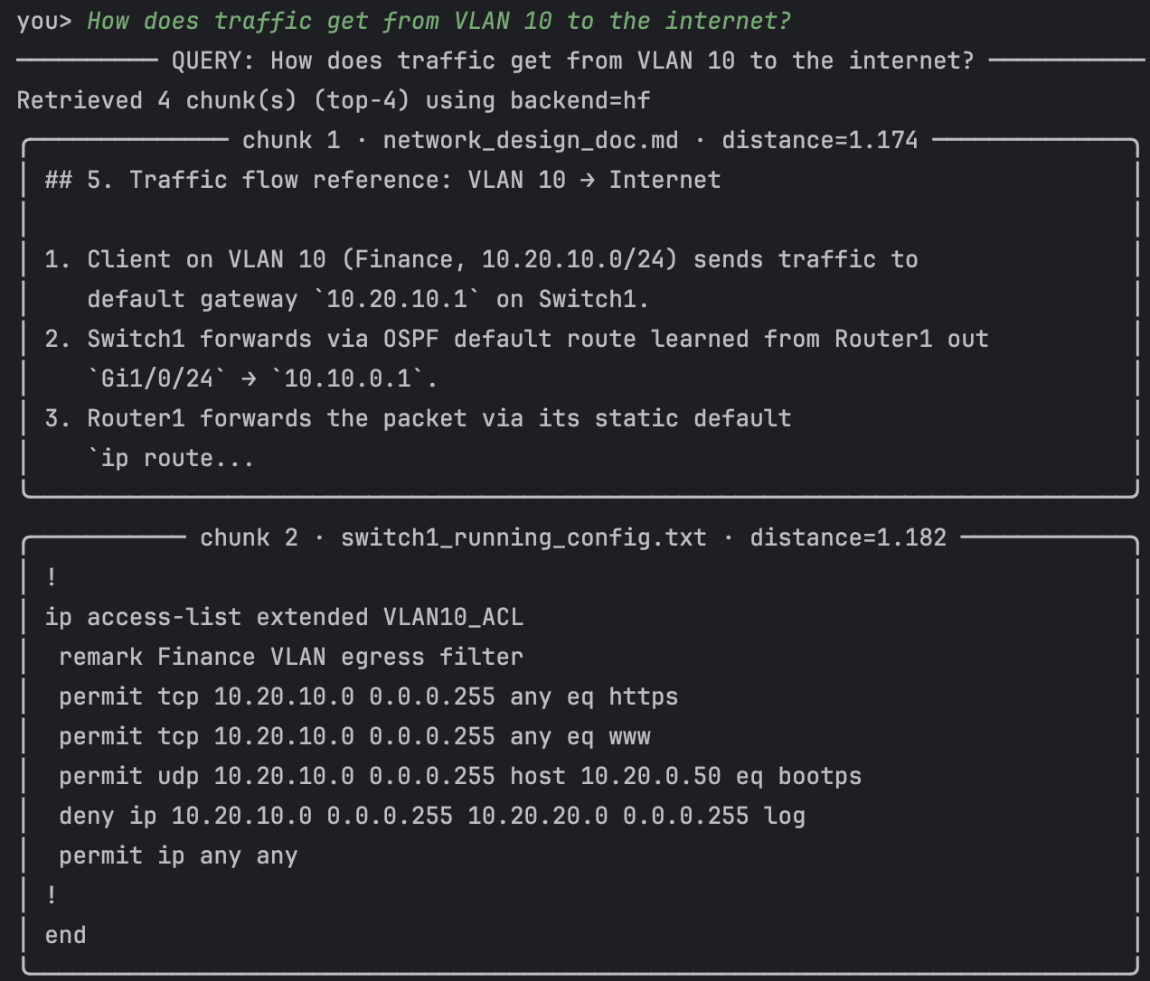
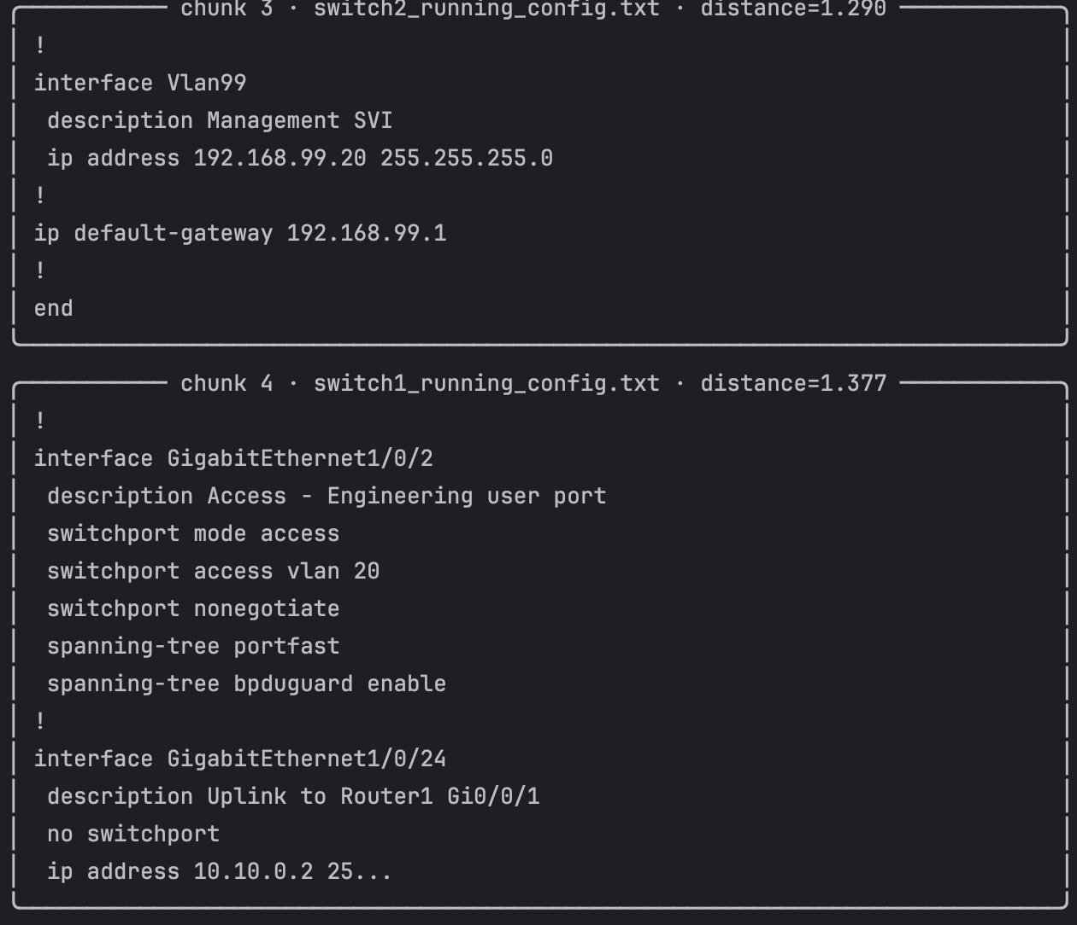
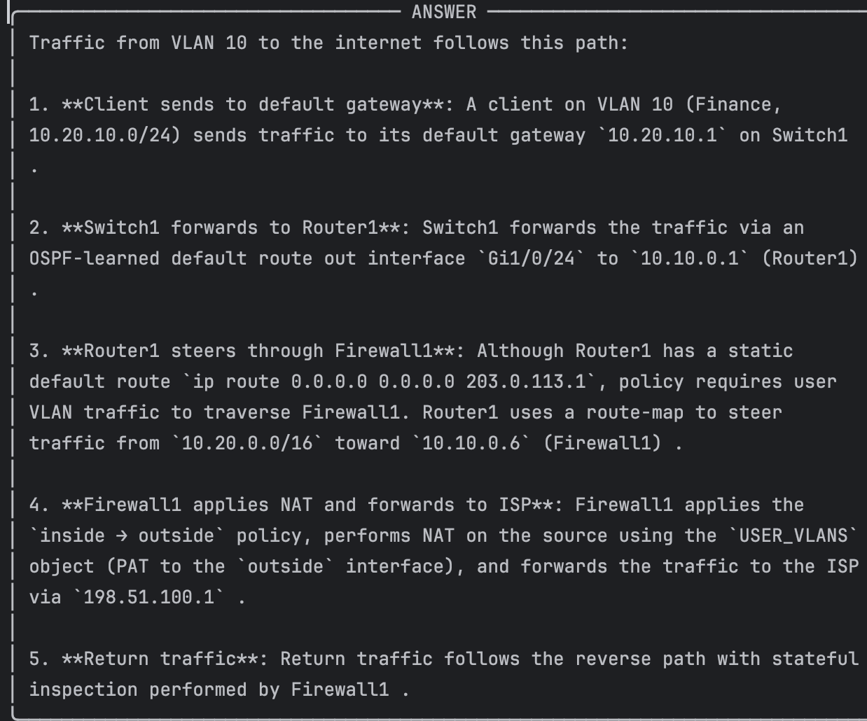
Context - This query specifically tests multi-document synthesis. The authoritative explanation lives in the design doc's "Traffic flow reference", but the VLAN-10 SVI and the NAT object-network live in the Switch1 and Firewall1 running configs respectively. Claude's answer drew the backbone of the narrative from the design doc (the retrieved chunks for §5) and backed it up with Switch1 for the gateway assignment. The NAT description is accurate per the design doc; Claude did not cite the firewall config directly because that chunk did not rank in the top-4 but it correctly grounded the claim via the design document. This is a good illustration of why design docs + configs together a better RAG corpus is than configs alone.
- A question the knowledge base cannot answer (to verify the AI does not hallucinate)
I asked about optics and we can see after verifying it answered without hallucination –
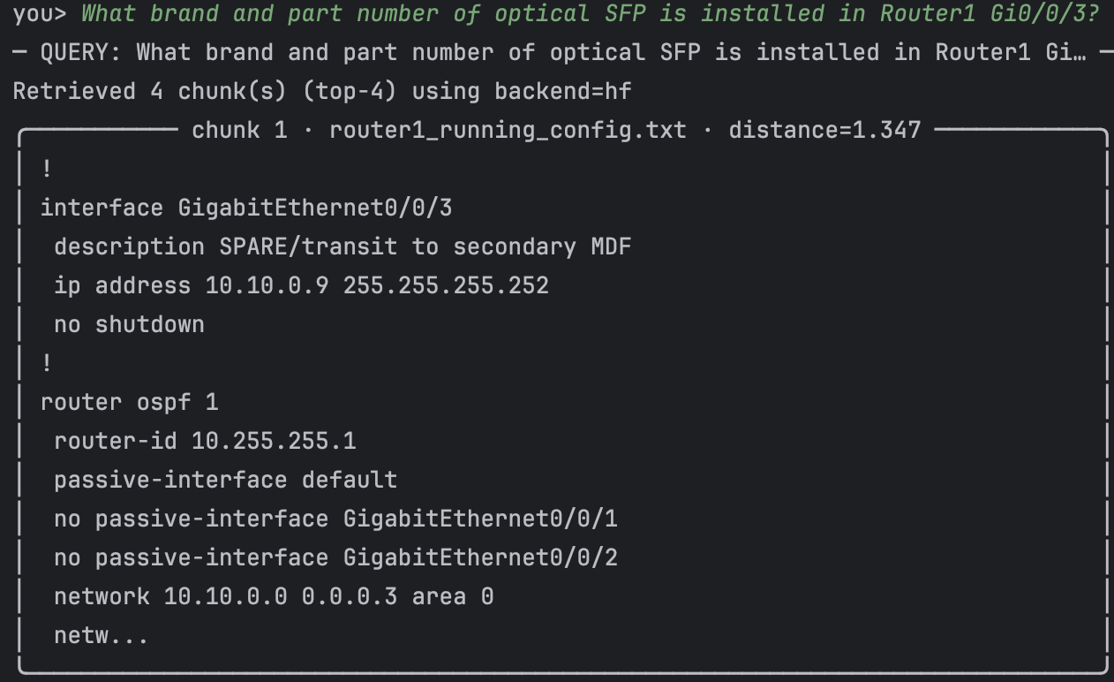
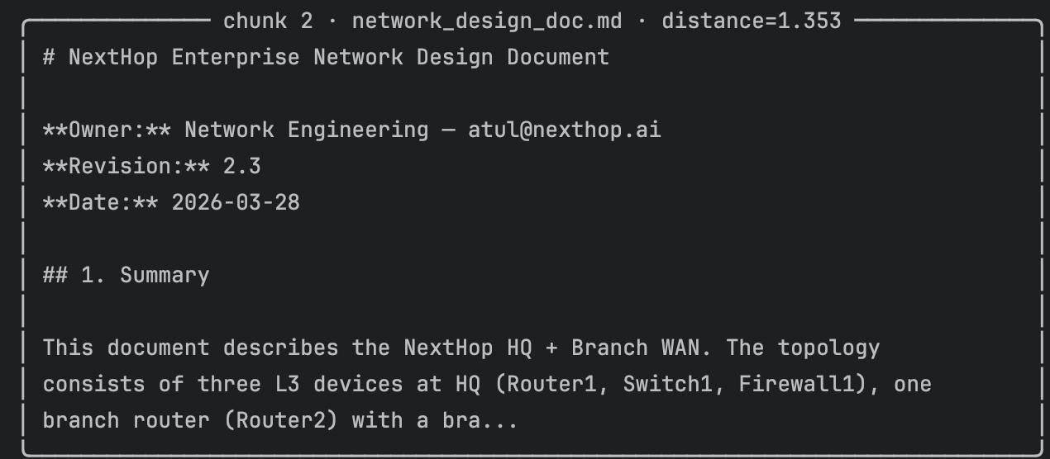
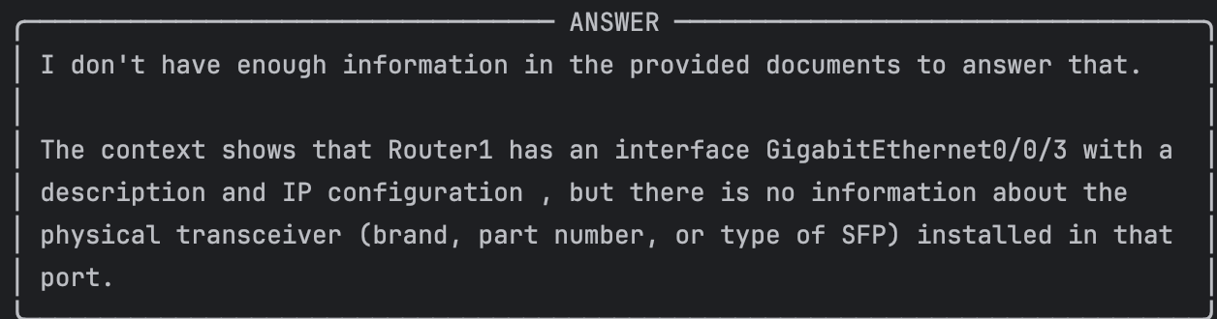

Context - This query exists to verify the assistant does not hallucinate. Nothing in the knowledge base says anything about SFP optics. The system prompt mandates a specific refusal sentence, and Claude produced it verbatim while still pointing the user at the closest relevant fact (the interface subnet) so the refusal is useful rather than blunt. This is the single most important behavior for production network AI: a confident wrong answer about interface optics could send an engineer to replace the wrong component at 2 AM.

Deliverable for Objective 2
- All Python source files (rag_assistant.py, any helper scripts)
Attached on the canvas
- The network documents used as your knowledge base
Attached on the canvas
- Screenshots or terminal output showing the 5 test queries with full AI responses and retrieved context
Attached above with context
- A written explanation (1 paragraph per query) describing what context was retrieved and whether the answer was accurate
I have answered this in above objective in line with screenshot
- A brief reflection (3-5 sentences): When would RAG be more appropriate than fine-tuning an LLM? What are the risks of using AI-generated answers for network operations?
RAG is the right tool when the authoritative answer changes faster than you can realistically retrain or fine-tune a model, and when the answer must be cited back to a source document the operator trusts. Running configs, design docs, VLAN plans, and runbooks all change on the order of days or hours, so a fine-tuned "network knowledge" model would be stale the moment it was shipped. Fine-tuning also smears facts together during training, making it hard to say which document a given sentence came from the opposite of what you want in an ops workflow where the engineer must defend a change to a change-advisory board. The risks of using AI-generated answers for network operations are serious and specific: a well-worded but wrong answer that sends an engineer to change the wrong interface, an answer that blends the current design doc with a stale one and produces a plausibly-correct but actually-impossible configuration, and in agentic setups like Objective 1 the ability to take action rather than just inform. Every production deployment of this pattern that I would trust has three properties: human-in-the-loop for any change, mandatory source citations that the engineer can click through to verify, and a hard refusal when the retrieval does not contain the answer. Objective 2's system prompt enforces the last two; the first is a process choice, not a technical one.

Setup details for the RAG
We can see below the ingest script created the database and entered the knowledge base data which will be available to query and quickly ask question from RAG -
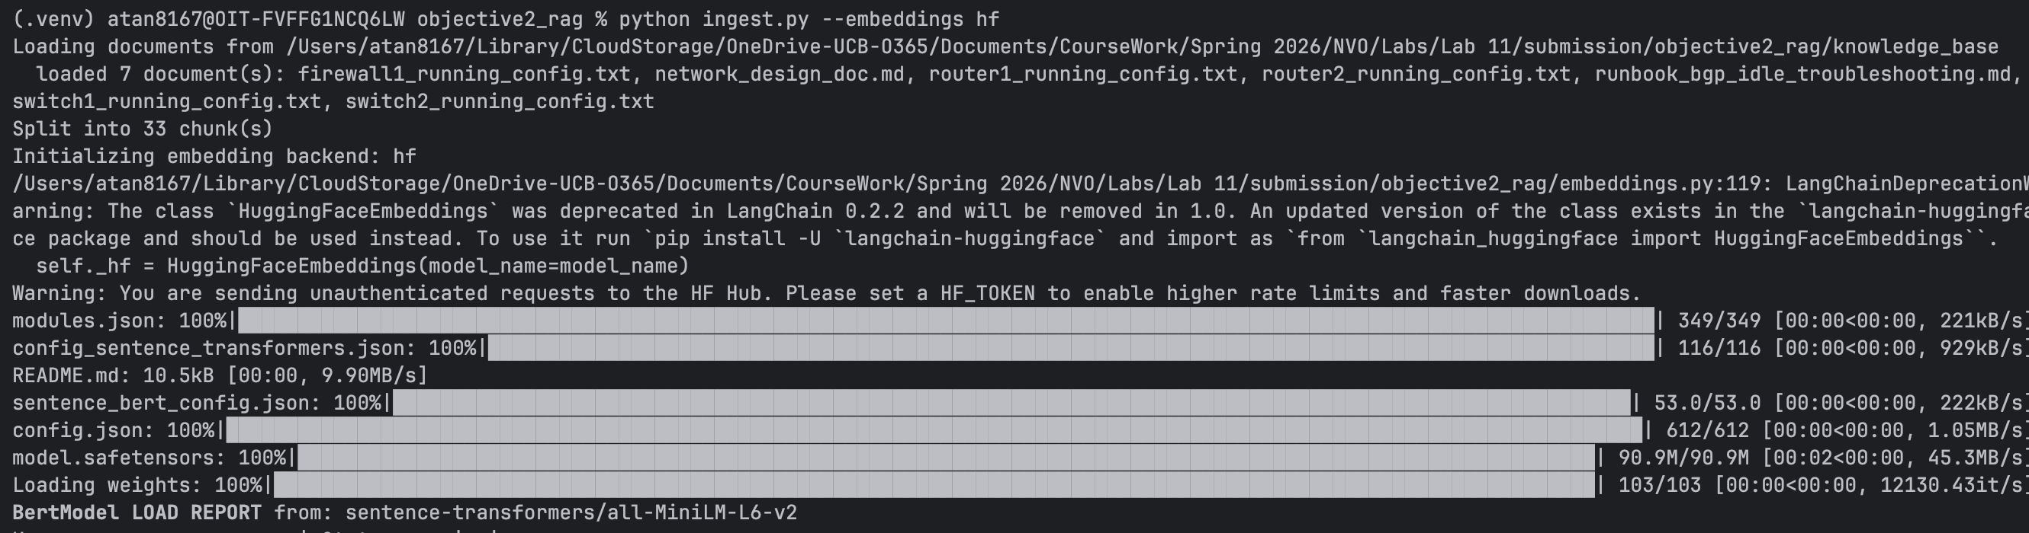
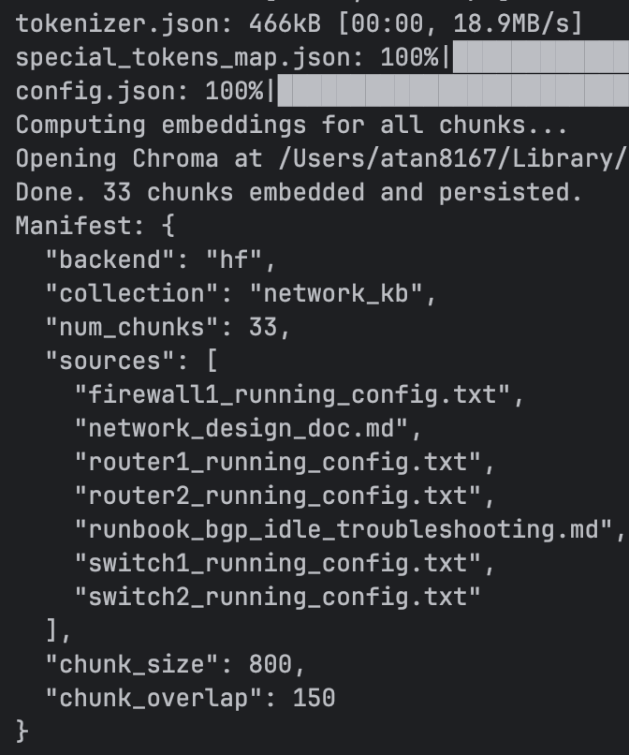

RAG modal running using hugging face -

I have a run all script which runs both of this objective and creates a html formatted output to look -

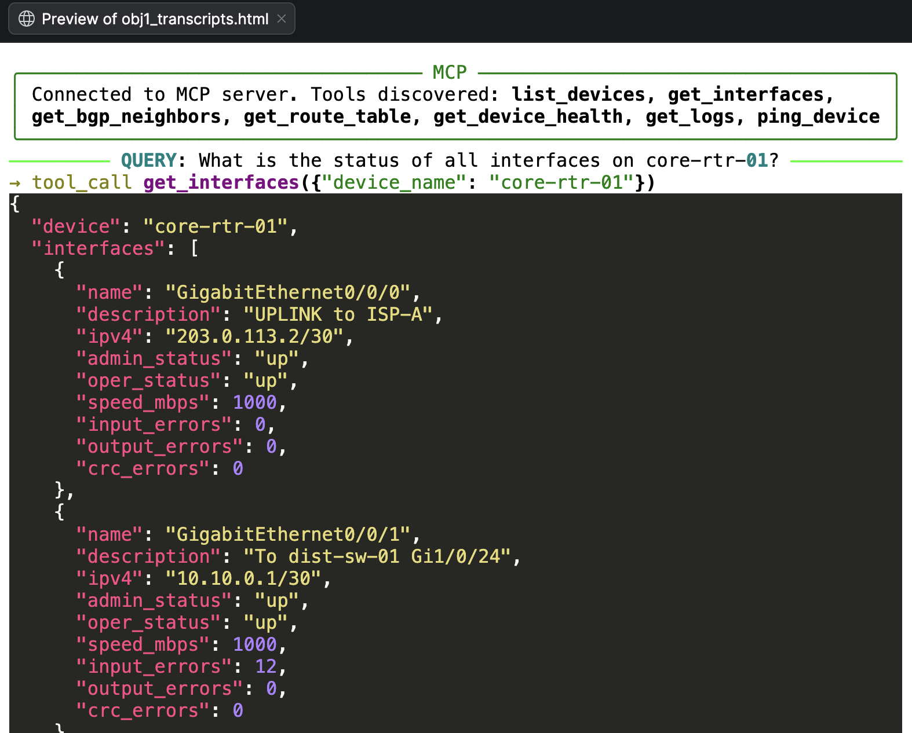

Bonus Option F: Combined MCP + RAG System (Extra Credit)
Combine Objectives 1 and 2 into a single unified assistant. Build a system where the AI can both:
- Query live network state through MCP tools (Objective 1)
- Reference network documentation through RAG (Objective 2)

This enables queries like: "According to our network design document, Router1 should have a BGP peering with AS65002. Can you check if that peering is actually up and healthy?"
The AI would use RAG to find the design intent, then use MCP tools to check the actual network state, and compare the two.

Deliverable for Bonus
- Combined Python source files
- At least 2 test queries that demonstrate the AI using both RAG and MCP tools in a single interaction
- Written explanation of how you integrated the two systems

Additional Extra Credit Options
Complete any of the following options for extra credit (10 points each, maximum 50 additional bonus points beyond Option F). Each option is independent. For each option you attempt, submit all source code, screenshots of working output, and a brief written explanation (1-2 paragraphs) of your approach and what you learned.
Option A: Build a Network Engineering AI Assistant with RAG (10 pts)
Build a Python chatbot that can answer questions about network configurations by combining an LLM API with Retrieval-Augmented Generation over your own network documentation. Upload router configs, runbooks, or RFCs, chunk and embed them, then query the LLM with relevant context. This is the same pattern used by production systems like Juniper Marvis, Cisco AI Assistant, and other AIOps platforms.
Tech stack: Python, LangChain or LlamaIndex, OpenAI/Anthropic API, a vector store (ChromaDB works locally).
Deliverable: Working chatbot that answers queries like “What interfaces on Router1 are configured for OSPF?” grounded in your actual configs. Submit source code, 3+ test queries with outputs, and a brief explanation.
Option B: Agentic Network Operations with MCP (10 pts)
Build a simple MCP (Model Context Protocol) server that exposes network operations as tools — things like “get interface status,” “check BGP neighbors,” “show route table” — backed by either a simulated network (GNS3/Containerlab) or mock data. Then connect an LLM client to the MCP server so the AI can autonomously query and reason about network state. The key learning outcome is understanding how agentic AI actually interacts with infrastructure through standardized tool interfaces.
Tech stack: Python, the MCP Python SDK, a simulated network or mock API, Claude or OpenAI as the LLM client.
Deliverable: Working MCP server + client where the LLM makes multi-step tool calls to investigate network state. Submit source code, 3+ test queries with full tool call traces, and a brief explanation.
Option C: Network Anomaly Detection with Streaming Telemetry (10 pts)
Build a supervised ML model that detects network anomalies from telemetry data. Use a dataset of network metrics — link utilization, packet loss, latency, jitter — labeled as “normal” or “anomalous.” Walk through all 7 steps of the ML workflow covered in lecture. You may generate or simulate the dataset if real telemetry data is not available.
Tech stack: Python, Pandas, Scikit-learn (or TensorFlow/Keras for LSTM-based time-series detection), Matplotlib for visualization.
Deliverable: Working model with accuracy metrics, a visualization of detected anomalies plotted on a timeline, and a brief explanation of model choice and results.
Option D: AI-Powered Network Config Generator and Validator (10 pts)
Build a Python tool that takes high-level network intent (e.g., “Create a BGP peering between AS65001 and AS65002 with route filtering for prefix 10.0.0.0/8”) and uses an LLM to generate vendor-specific configurations, then validates them against a schema or by pushing to a lab environment. This combines your existing Python/automation skills with LLM integration and directly addresses intent-based networking. Students learn both the power and the limitations of LLM-generated configs (hallucination, syntax errors) and why human-in-the-loop matters.
Tech stack: Python, OpenAI/Anthropic API, Jinja2 templates for validation, optionally Netmiko/NAPALM to push configs to a lab.
Deliverable: Working tool that generates configs from 3+ intent statements, validates them, and reports errors or pushes to a lab. Submit source code, example intent-to-config outputs, and a brief explanation of validation approach and any hallucination issues encountered.
Option E: Predictive Network Capacity Planning with ML (10 pts)
Use historical (or simulated) network utilization data to build a time-series forecasting model that predicts when links will reach capacity. This is a direct AIOps use case — the kind of predictive analytics that Splunk ITSI and Datadog perform in production. Forecast link utilization 24-72 hours ahead and identify which links will hit capacity thresholds, then present recommendations.
Tech stack: Python, Pandas, TensorFlow/Keras (LSTM) or Facebook Prophet for time-series forecasting, Matplotlib for visualization.
Deliverable: Working forecasting model with visualizations showing predicted vs. actual utilization, identified capacity thresholds, and recommendations. Submit source code, charts, and a brief explanation of model choice and accuracy.

Submission
Submit a single ZIP file containing:
- This lab document with all screenshots, outputs, and written explanations inline
- All Python source files for both objectives
- Your network documents/configurations used for the RAG knowledge base
- A README.md explaining how to install dependencies and run your code
- (If applicable) Extra credit option source files, outputs, and written explanations in clearly labeled folders (e.g., option_a/, option_b/)

